HOSPITAL PATIENT RECORDS ANALYSIS
Project Report
Prepared by: Dhanushkumar S
Project Type: Data Analytics
Tools Used: Microsoft Excel, MySQL
Date: October 2026

1)Introduction
The Hospital Patient Records Analysis project focuses on analyzing patient admission records, hospital departments, length of stay, revenue, and insurance categories. The objective is to transform raw patient data into meaningful insights using SQL queries and Excel dashboards.

2) Project Objectives
- Analyze the total number of patients admitted.
- Identify departments with the highest patient admissions.
- Calculate average patient length of stay.
- Analyze hospital revenue by department.
- Understand insurance category distribution
- Build an interactive Excel dashboard for reporting

3) Tools and Technologies
Microsoft Excel: Data cleaning, formulas, PivotTables, charts, slicers, and dashboard creation.
MySQL: Data storage, SQL queries, aggregations, filtering, grouping, and analysis.

4) Dataset Description
The dataset contains hospital patient records with fields such as Patient ID, Name, Age, Gender, Admission Date, Discharge Date, Department, Diagnosis, Insurance Type, and Billing Amount, depending on the available dataset.
PAGE NO:1
5) Methodology
- Created and prepared the hospital patient dataset.
- Cleaned and checked the data in Excel.
- Imported the dataset into MySQL.
- Wrote SQL queries to analyze patient records.
- Summarized the results using PivotTables and charts.
- Developed an Excel dashboard with KPI cards and interactive filters.

6) Dashboard and Analysis
- Total Patients
- Average Length of Stay
- Total Revenue
- Number of Departments
SCREENSHOT
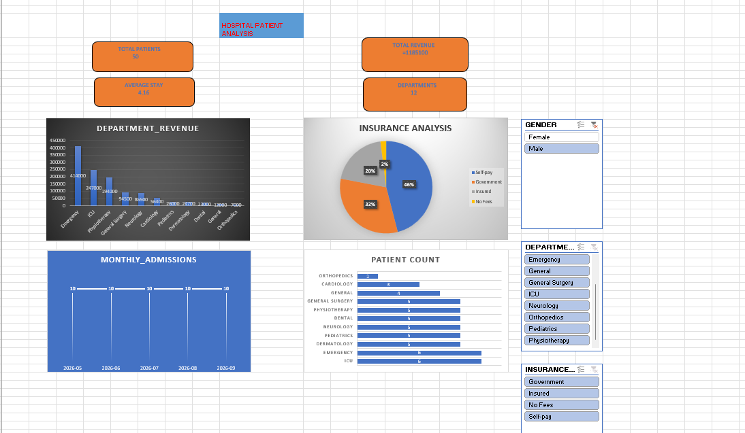

PAGE NO:2

.
7) Skills Learned
SQL, MySQL, Excel, data cleaning, PivotTables, charts, Slicer,KPI development, dashboard design, and data interpretation

PAGE NO:3

